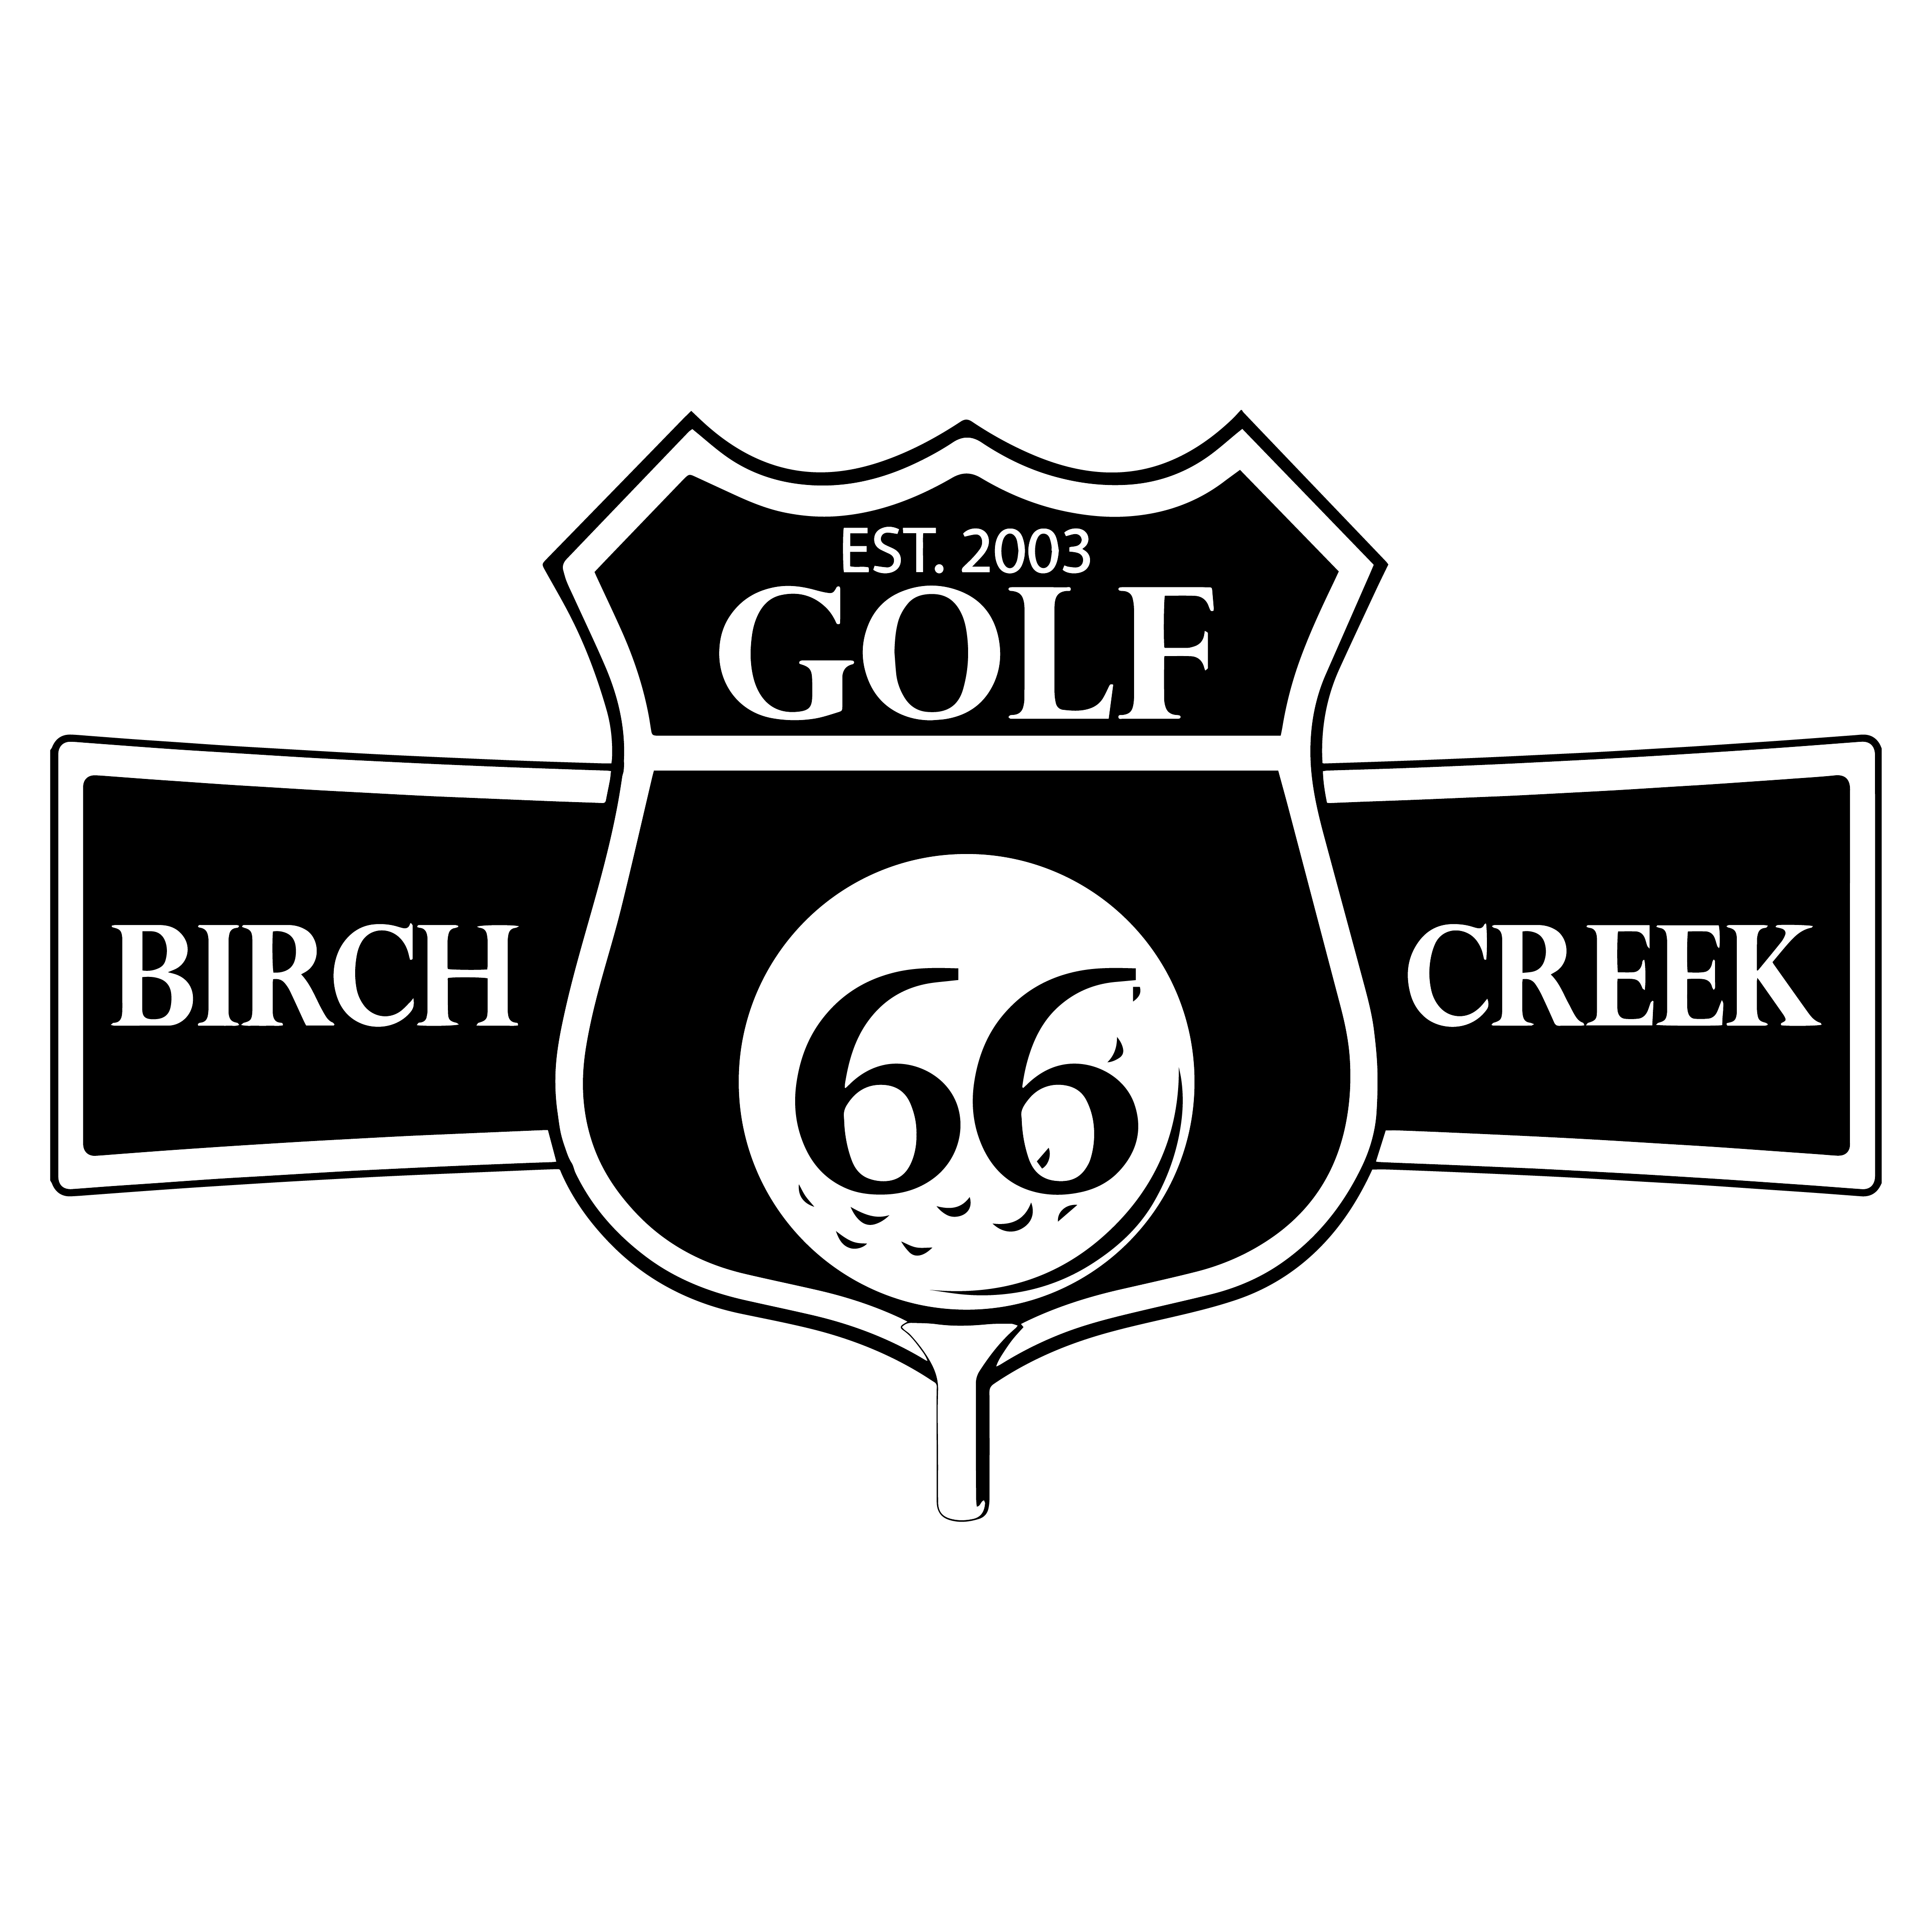
Birch Creek Golf Club

BC Championship – 27 Hole Stroke Play
Sunday, September 15, 2024

This is a cash prize event. Please bring cash entry.

- USGA Rules of Golf are in effect for this event.
NOTE: The “Rules of Golf” are not dependent upon course conditions. You may get an occasional bad lie. This is part of the game and is the same for all.
Please verify with others when taking relief. Use USGA prescribed relief only.
- This tournament consists of 27 holes at stroke play, beginning on #1.
- Play will be continuous with only 5 minute breaks at the turns.
- Prizes will be paid for each 9, and 27 hole total.
- Exchange scorecards. Verify, sign and attest. You are responsible for your score.
- CHAMPIONSHIP on Black tees.
- Mens Division on Blue tees.
- Senior Division on White (60+) or Gold Tees (70+).
Rules questions cannot hold up play. If you cannot determine the proper ruling play a provisional and request a ruling before the final scores are posted. You may call the Pro Shop for advice. 636-584-7200.
- Food and Drink will be provided after play. GOOD LUCK.

50% of entry fees will be paid in cash prizes.

BCGC will add bonus to Championship Flight
in the form of Golf Credit for future play.
1st, 2nd, 3rd are guaranteed $1,000, $600, $400 combined cash and credit. Other Champ Flight players get $75 credit plus cash winnings.
Prizes are awarded for each 9 holes, 27 hole total, and Skins

